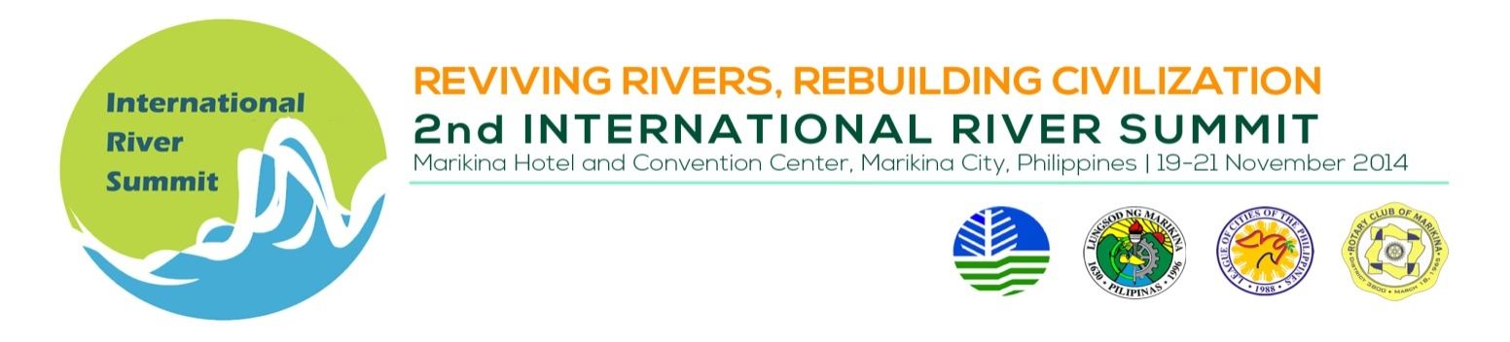
INDICATIVE PROGAMME

Thematic Session 7 : Biodiversity Conservation in River Revival

Venue : Session Rm.1, Ground Flr, Convention Center

Date/Time : November 20, 2014, 1:30 – 5:00 PM

Session Chair : Dr. Theresa Mundita S. Lim, Director, Biodiversity Management
Bureau
Session Co-Chair : Dr. Donna Paz Reyes, Director, Environmental Science Institute,
Miriam College, Philippines

TIME | TOPIC | SPEAKER
 | SESSION INTRODUCTION | Dr. Theresa Mundita S. Lim
 | Status of fish biodiversity in Philippine rivers: challenges and problems | Ms. Desiree Eve R. Maaňo, Senior Ecosystems Management Specialist, Biodiversity Management Bureau, DENR Philippines
 | The Iloilo River: Development over environment? | Dr. Jurgenne Primavera, Chief Mangrove Scientific Advisor, Zoological Society of London/ Specialist Group of International Union for the Conservation of Nature
 | Biodiversity Assessments and Monitoring  of Freshwater Ecosystems in the Philippines | Dr. Perry Ong, Institute of Biology, University of the Philippines, Quezon City, Philippines
 | BREAK
 | Priority Actions to Address Biodiversity Loss in Inland Wetlands | Ms. Annabel Plantilla  Consultant to the DENR Biodiversity Management Bureau, DENR, Philippines
 | River Ecosystem and Wildlife Management | Engr. Subijoy Dutta, P.E. (presenter)/ Matthew Perry, Emeritus Scientist (author) United States Geological Survey, Patuxent Wildlife Research Center, Maryland, USA
 | The Biological Diversity and Ecosystem Resilience of Yamuna River, India | Ms. Monisha Isaac,  Jacob School of Biotechnology and Bioengineering, Sam Higginbottom Institute of Agriculture, Technology & Sciences, India

